2015 North Portland Neighborhood Services Grants Information

Is my project eligible for funding?
Grant funded projects must:
1. Serve residents in the North Portland Neighborhood Services District (see map)
2. Start in January 2016 and be completed by December 2016.
3. Meet one or more of the following three criteria:
- Build community
- Engage new and diverse communities,
- Sustain those already involved; strengthen existing programs
- Increase community and neighborhood impact on public decisions and community life

Collaboration with other organizations is encouraged.

North Portland Neighborhood Services grant funds may not be used for any costs the applicant may incur in preparing the application, direct social services, ongoing organizational operations, grants, loans, debt retirement, fund drives, emergency funding, and/or capital projects.

How much funding is available for my eligible project?
$20,000 in funds will be granted this funding cycle. Grants awarded are typically less than $4,000.
Over the past 15 years, North Portland Neighborhood Services has granted over $400,000 to community programs in the North Portland Neighborhood Services District.

How can I get help with the application form?

You are encouraged to attend the free North Portland Neighborhood Services grant writing workshops:

Tuesday, September 22 7:00-8:00 p.m. at the Historic Kenton Firehouse
8105 N. Brandon St.
Wednesday, October 7 7:00-8:00 p.m. at the Historic Kenton Firehouse
8105 N. Brandon St.
Or call for an appointment.

You will learn about grant writing, the application and selection process, meet committee members, learn about other projects seeking grant funding for possible collaboration, and learn how to get individual help with your grant.

Please call seven days in advance for special needs accommodations, for people with disabilities at 503-823-4519 or TTY 503-823-6868. The Historic Kenton Firehouse is wheelchair accessible.

Public Transit: Tri Met Bus #4, Bus #75 and Max Yellow line.

Call Mary at 503-823-4099 or email mary@npnscommunity.org with questions.

Who can apply?

Neighborhood and community organizations are eligible to apply. Higher consideration will be given to proposals submitted on behalf of and in direct partnership with one or more of the following:
- Neighborhood associations
- Emerging grass roots community building and/or civic engagement organizations
- Organizations engaged in community building and/or civic engagement activities
- Business associations or business organizations engaged in community building activities and/or civic engagement activities

How do I apply?

An application form must be submitted for a project to be considered for award.
Application forms must be received no later than 2 p.m. Monday, November 2, 2015.
Applications submitted after the 2 p.m. deadline will not be accepted.

The responses to the application questions should give the selection committee of North Portland Neighborhood Service District residents an understanding of the proposed project, project funding priorities, as well as the size, scope and partnerships involved. Committee members may contact grant applicants during the review process for additional information and/or to suggest potential partnership opportunities.

Application forms and instructions are available at www.npnscommunity.org or by contacting mary@npnscommunity.org
Printed copies are available from North Portland Neighborhood Services, 2209 N. Schofield St. 503.823.4099.

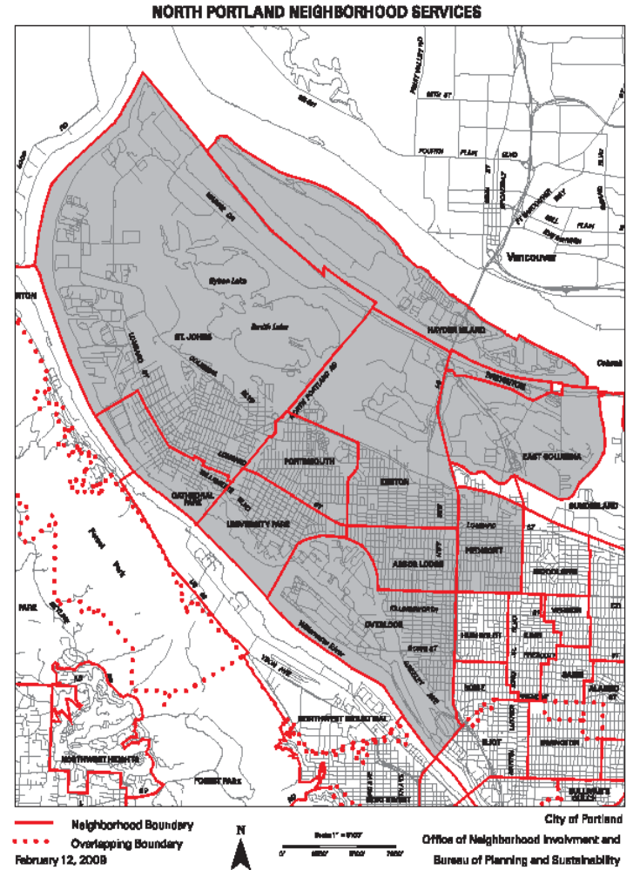

North Portland Neighborhood Services Grant
Application Instructions

North Portland Neighborhood Services seeks applications for projects that benefit North Portland residents and neighborhoods.

The information requested in each section of the application form is described below. The application form can be submitted electronically unless an exception is requested. After completion, save your form, attach it to an email, and email to mary@npnscommunity.org. We will confirm receipt of your application. If further clarification is needed, call Mary Jaron Kelley at (503) 823.4099.
Application forms must be received no later than 2 p.m. Monday, November 2, 2015.
Applications submitted after the 2 p.m. deadline will not be accepted.

General guidelines
- Answer all questions and complete the budget. Do not submit additional materials.
- Limit answers to space provided. Use 10 or 12 point font.

Applicant information

- For Project Title briefly describe intent of project or program (e.g., “Neighborhood Fruit Tree Harvest & Share”) in one sentence.
- List the Neighborhood (s) that the project will serve. Projects must serve residents in the North Portland Neighborhood Services District (See Map).
- Identify the Organization or group requesting funds.
- 501 (c) (3) federal tax status or a fiscal sponsor that is a 501 (c) (3) charitable corporation is required to provide accounting and contractual support. If you need a fiscal sponsor, please contact Tom Griffin-Valade, tom@npnscommunity.org.
- Project coordinator (s) is responsible for directing the project’s scope of work and reporting outcomes to North Portland Neighborhood Services.
- Provide project coordinator’s email address and phone number.
- Provide alternate coordinators if relevant, and contact information.
- Include partner organization (s), if relevant.

Project budget

Calculate the amount of grant funds requested from North Portland Neighborhood Services, the amount of in kind support, and the amount of other funds that will be contributed to the project. Show how grant funds will be used to purchase items and services in support of proposed project.

In-Kind Support: Donated services and time can include estimated dollar amount of in-kind donations and/or general volunteer hours at $23.07 per hour. For professional or skilled volunteer work, visit www.bls.gov/oes/current/oes_or.htm to identify a median per hour volunteer rate.

- Personnel costs are salary or wage expenses for staff positions directly related to proposed project.
- Overhead costs may include utilities, advertising, rent, telephone bills, or other administrative costs directly related to project (e.g., accounting, fiscal management).
- Professional services are salary or wage expenses for functions performed by independent contractors.
- Material, equipment, supplies include items to be purchased or rented for proposed project.
- Transportation or travel costs may include hours for travel time. Mileage rate of $0.57/mile applies.
- Other is the category for those costs that do not fit into any listed category.

North Portland Neighborhood Services funds may not be used for any costs the applicant may incur in preparing the application, direct social services, ongoing organizational operations, grants, loans, debt retirement, fund drives, emergency funding, and/or capital projects.

Reporting Requirements:
- Final Report: After the completion of the project, each grantee must complete a two-page end-of-project evaluation and expense report and submit it to the coalition office that awarded the grant. This final report must be turned in by January 31, 2017. If you complete your project earlier, we encourage you to complete and turn in your final report within 30 days of the completion of your project.

- Photograph(s): Provide at least one photograph (preferably in electronic format) of your project activities along with your completed final report.

2015 North Portland Neighborhood Services Grant (NPNSG)
Application Form Cover Sheet

General guidelines
- Answer all questions. Do not submit additional materials
- Limit answers to space provided. Use 10 or 12 point font.

Section 1 - Applicant Information

Grant review committee members may contact you with questions regarding your application.

Applicant information
Project Title
Neighborhood(s) Served
Organization
Grant Funds Requested: $
501c3 status Yes No | Fiscal Sponsor Yes No
Project Coordinator(s)
Email |  | Phone
Alternate Coordinator(s) if relevant
Email |  | Phone
Partner Organization(s) if relevant

Section 2 - Briefly describe the project and how the funds will be used as indicated in the budget. Use this space to provide a narrative of the project with relevant budget itemization.

- Section 3 – Explain how this project will meet one or more of the funding requirements:
Create and build community, Engage new and diverse communities, Sustain those already involved, Strengthen existing programs, Increase community and neighborhood impact on public decisions and community life.

Section 4 – Describe who will benefit from this project? How many people will be engaged? How will outreach be conducted? How will the project welcome diversity?

Section 5 –Provide a simple timeline for your project, including your expected start and completion dates and any major project milestones.

Section 6 – Explain how collaborating organizations or partners will be involved in the successful implementation of the grant project. Include a contact name, phone, and email for each partner organization, if relevant.

Section 7 – Describe how you will implement your project if not fully funded. What are the priorities for this project?

Section 8 – What impact will the project have on the North Portland community after the requested grant funds have been used?

Budget

Note: the budget must relate to the narrative in the above sections.

Item/Service/Expense | Requested  funds | Matching funds  CASH | Matching funds  IN KIND | TOTAL
Personnel  Staff salaries, direct project management, volunteer labor (show hourly rates, total hours). | $ | $ | $ | $
Overhead costs  Utilities, advertising, rent, telephone bills, administrative costs directly related to project (e.g., accounting, fiscal management). Show estimated cost for each item listed. | $ | $ | $ | $
Professional services  Functions performed by independent contractors. | $ | $ | $ | $
Materials, equipment, supplies  List items, quantities, prices. | $ | $ | $ | $
Transportation or travel costs  Itemize. Mileage rate of $0.57/mile applies. | $ | $ | $ | $
Other  Describe, itemize. | $ | $ | $ | $
TOTAL | $ | $ | $ | $
Total Requested Funds column must match the Grant Funds Requested in Section 1 of the application.

In-Kind Support: Donated services and time can include estimated dollar amount of in-kind donations and/or general volunteer hours at $23.07 per hour. For professional or skilled volunteer work, visit www.bls.gov/oes/current/oes_or.htm to identify a median per hour volunteer rate.

